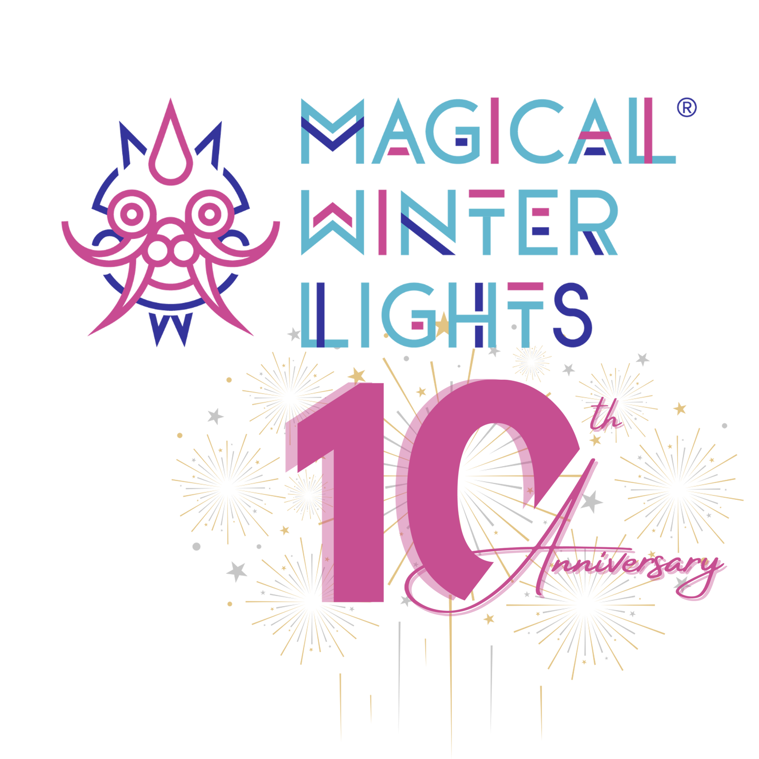

FOR IMMEDIATE RELEASE

**Magical Winter Lights Moves to New Location at Fort Bend County Fairgrounds**

**November 15, 2024 - January 5, 2025**

**Rosenberg, TX (Oct. 10, 2024)**  – The beloved holiday spectacle of Magical Winter Lights, celebrating its 10th Anniversary, will occur at the Fort Bend County Fairgrounds from November 15, 2024, to January 5, 2025. The new location promises an enhanced experience for visitors, offering more space, ample parking, and new lantern displays that will transport guests into a dazzling winter wonderland like never before.

“We are beyond excited to bring Magical Winter Lights to the Fort Bend County Fairgrounds,” said Yusi Cheng, the event organizer. “This new location allows us to create an even more magical experience for Fort Bend County residents and the Greater Houston area, with plenty of room for expanded displays, easier access, and convenient parking.”

With this move, the 2024 event will feature a host of fresh surprises, including an array of new, larger-than-life lantern displays, celebrating both the holiday season and various global cultures. Fans of the event will also be delighted by the return of the highly entertaining acrobatic show, which adds an extra layer of thrill and spectacle to the experience.

In addition to these exciting updates, the festival will continue to showcase its iconic attractions, such as the grand entrance castle, the popular dinosaur exhibit, and Houston-themed displays that have become a staple of the event. The family-friendly carnival also returns, bringing joy with games, rides, and festive treats.

Magical Winter Lights invites families and friends to experience the magic like never before, creating unforgettable memories that will last a lifetime. Early bird tickets will go on sale on October 18, offering special pricing for those who want to secure their spot early. Group tickets and other special packages are also available. For more information or to inquire about ticket sales, visit www.magicalwinterlights.com. Follow along on social media for event updates and exciting news as the holiday season approaches!

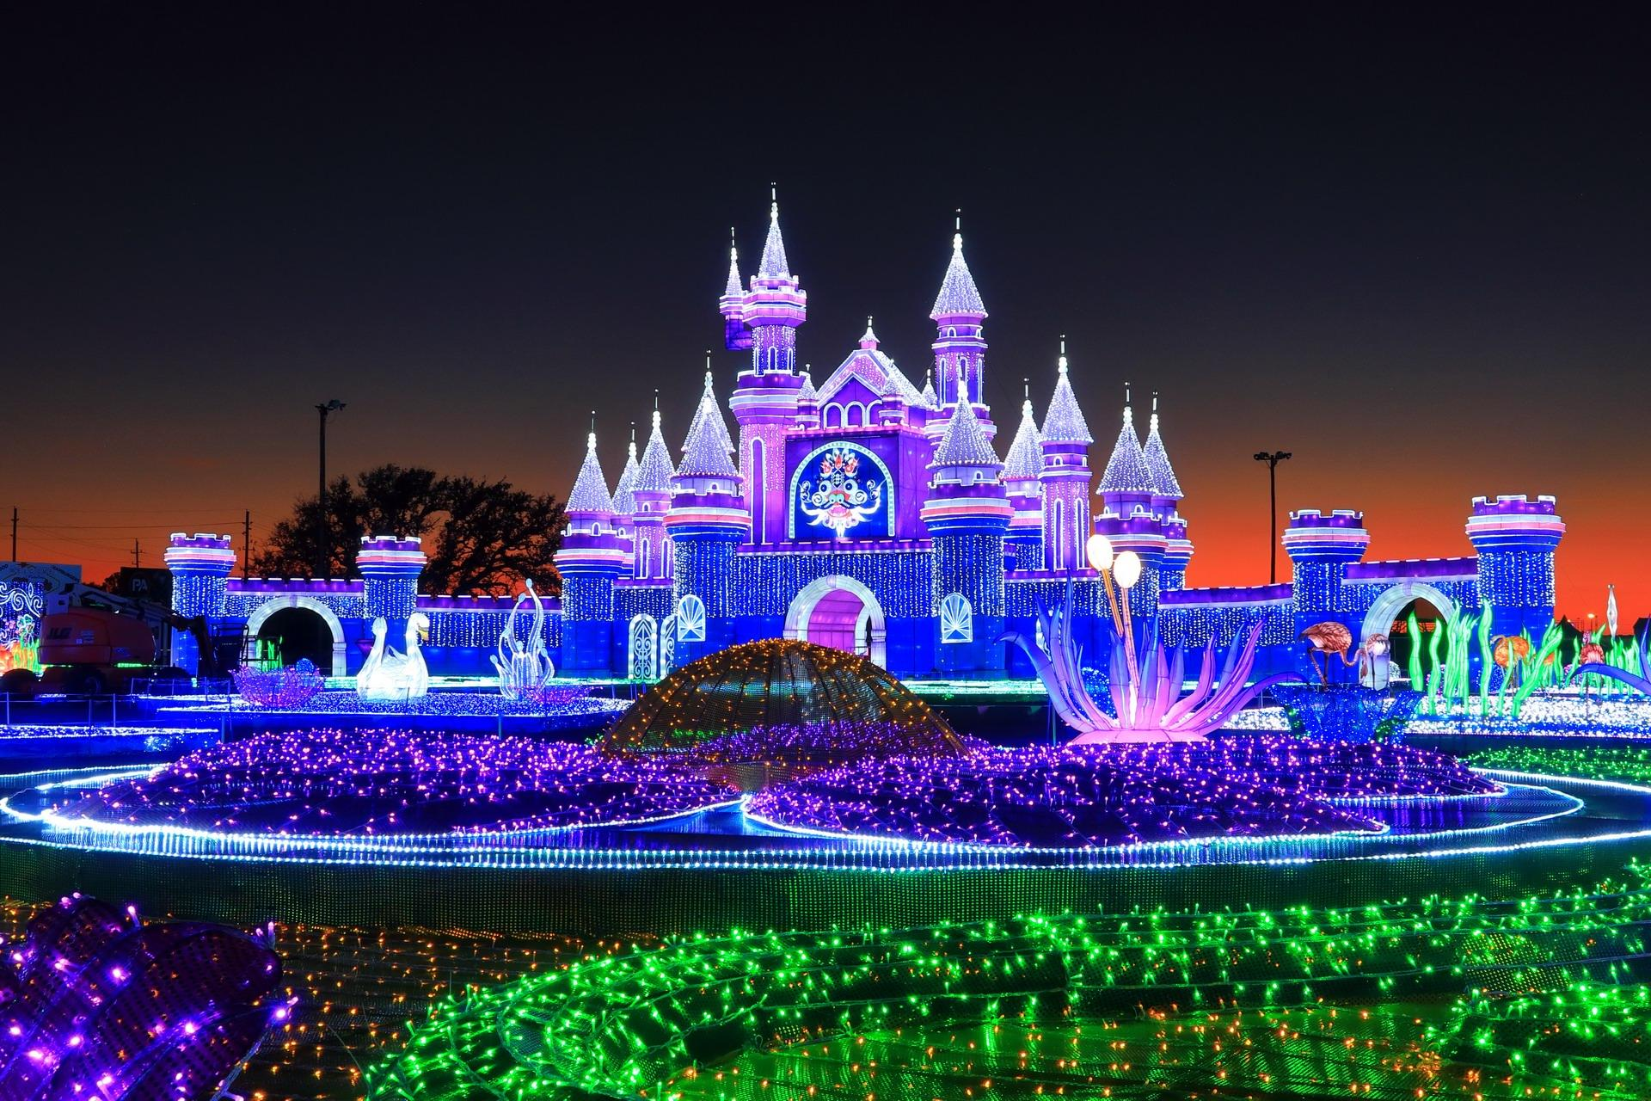

###

Contact:

RoShelle Salinas

Magical Winter Lights PR

roshelle@salinassolutions.com

281-509-1682